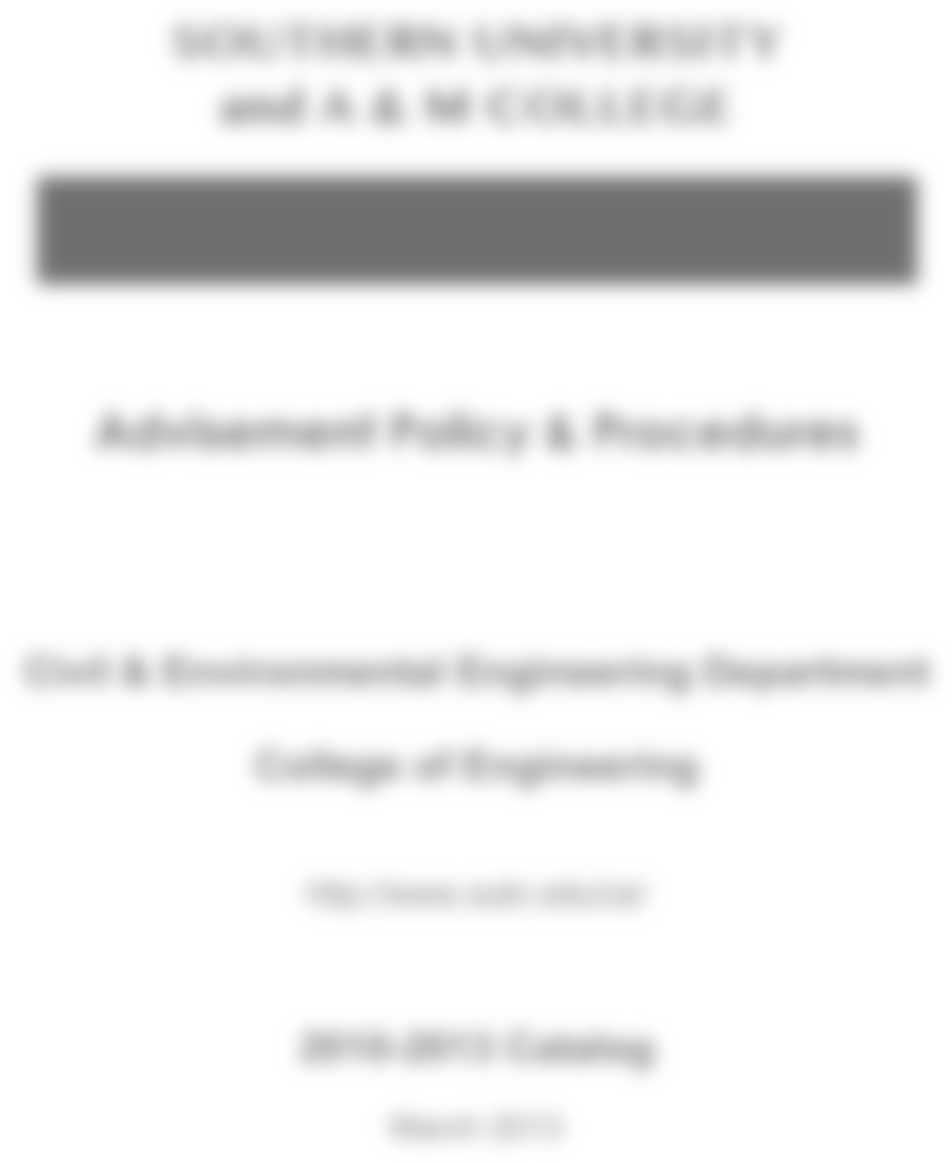

Graduation Application Package

Civil & Environmental Engineering Department
College of
Sciences and
Engineering
http://www.subr.edu/ce/

201
7
-20
20
Catalog
August 2021

Academic Advisement Procedures
The academic advisement procedures in the Civil & Environmental Engineering (CEE) department include the following components:
1. All students admitted to the Civil Engineering (CE) program are assigned to an academic advisor on an alphabetical basis. Table -1 presents the assignment of Civil Engineering Academic Advisors to respective student categories as presented In Table 1.

Table 1 - Civil Engineering Academic Advisors
Student's  Last Name  Beginning With |  |  | Office Location | E-mail & Phone Number
 |  | Academic Advisor
A-H | Mr. Ron Lee |  | Room 315 | Ron_lee@subr.edu (225) 771-4035
I-Q | Dr. Chukwu Onu |  | Room 312 | Chukwu_onu@subr.edu  (225) 771-4325
R-Z | Dr. Hang Yin |  | Room 313 | Hang_yin@subr.edu (225) 771-3790
Transfer Students | Dr. Hak-Chul Shin |  | Room 307 | Hakchul_shin@subr.edu  (225) 771-2112
All Senior Students | Dr. Hak-Chul Shin |  | Room 307 | Hakchul_shin@subr.edu (225) 771-2112

- Academic advisors provide information and guidance to students concerning the CE program and they also approve students’ schedule of classes throughout their matriculation in the program. All CE students are required to meet with their academic advisor early during registration periods; wherein they complete and initial a Registration Advisement Form to acknowledge the advisement encounter. This form is attached to the set of procedures. It should be noted that all students must first be cleared by their assigned academic advisor before being authorized to use regular registration, cross-registration, or telephone registration.
- The academic advisor will use a department "Degree Requirements Record Form” that is based on the appropriate curriculum taken from the student's chosen graduation checkout catalogue.
- The Banner academic support and records system offers such services as on-line academic records, class schedule, student demographic data, degree curricula, interactive registration, degree audits, course descriptions, and course prerequisites.

2

Degree Requirements
The Bachelor of Science Degree in Civil Engineering (BSCE) is awarded to students who complete the requirements of the program as stated below:
- Complete the CE-curriculum requirements with a minimum overall grade point average of 2.00 out of 4.00. The total credit hours required for graduation is 128 credit hours;
- Pass the Writing Proficiency Examination (WPE, ENGL 001) prior to applying for graduation. The Writing Laboratory located in Harris Hall, Room 109, is a resource to prepare students to pass the WPE;
- Pass the Departmental Comprehensive Examination (DCE, CIEN 000) that is administrated by the Civil & Environmental Engineering department. The Departmental Comprehensive Examination can be substituted with registering FE Exam and passing the Exam before the Departmental Comprehensive Examination. If students fail the FE Exam, students should pass the Departmental Comprehensive Examination.
- Complete the University mandated African-American Experience. Courses that satisfy the African-American Experience requirement are listed in the 2017-2020 Curriculum. Note that the English and Music courses that are listed can be taken to satisfy the African American Experience as well as English literature and Music elective requirements. See the current university catalogue for details.
- Complete the University mandated Community Service Requirement. It is required to complete a minimum of 60 clock hours of COMMUNITY SERVICE as one of the requirements for graduation. Service Learning courses are: Service Learning 100, 200, and 300, (Credit, 1 Hour, each); and Service Learning 400, (Credit, 3 Hours). A total of three semester hours of credit is required. Waivers:
  - Students who were first-time freshmen at any post-secondary institution before August
1, 1991;
  - International Students;
  - Those students 25 years of age or older who completed high school or who earned high school equivalency seven or more years prior to admission;
  - Any person with certifiable disability of such nature that community service projects would jeopardize the welfare of the parties involved.

General Education Requirements
The degree requirements of Civil and Environmental Engineering are provided in the back side of 2017-2020 curriculum.
3

Department of Civil & Environmental Engineering 2017-2020 Curriculum – Degree Requirements Worksheet
Southern University and A&M College MATH 264 – First Semester – 8 Semesters to Graduation
Name: ________________________________ Proposed Date of Graduation: ____ / ____ / ________
S Number: __________________________ Advisor: ___________________________
Term |  | Grade | Sem | Year | Dept | No | Course | Credit | Pre- (Co-) Reqs | Comments
FRESHMAN | FAL  (1)  16.0 |  |  |  | BIOL |  | Life Science Electiveª | 3
 |  |  |  |  | SCHE | 132L | General Chemistry Lab | 1 | (SCHE 132)
 |  |  |  |  | SCHE | 132 | General Chemistry Lecture | 3
 |  |  |  |  | SENL | 101 | Freshman Composition I | 3
 |  |  |  |  | ENGR | 120 | Freshman Engineering I | 2
 |  |  |  |  | SMAT | 211 | Calculus I | 4
 | SPR  (2)  16.0 |  |  |  | ECON |  | Economics Elective ª | 3
 |  |  |  |  | SENL | 102 | Freshman Composition II | 3 | SENL 101
 |  |  |  |  | ENGR | 130 | Freshman Engineering II | 2 | ENGR 120
 |  |  |  |  | SMAT | 212 | Calculus II | 4 | SMAT 211
 |  |  |  |  | SPHY | 213 | General Physics I Lecture | 3 | SMAT 211
 |  |  |  |  | SPHY | 213L | General Physics I Lab | 1 | (SPHY213)
SOPHOMORE | FAL  (3)  17.0 |  |  |  | CIEN | 201 | Surveying | 3 | (SMAT 211)
 |  |  |  |  | CIEN | 224 | Statics | 3 | SMAT 212 SPHY 213, 213L
 |  |  |  |  | CIEN | 311 | Comp Aided Methods in CE | 3 | ENGR 130
 |  |  |  |  | ENGR | 230 | Tech Communications | 2 | SENL 101
 |  |  |  |  | ENGR | 320 | Probability & Statistics | 2 | SMAT 212
 |  |  |  |  | SPHY | 215 | General Physics II Lecture | 3 | SMAT 212 SPHY 213
 |  |  |  |  | SPHY | 214L | General Physics II Lab | 1 | (SPHY215)
 | SPR  (4)  16.0 |  |  |  | CIEN | 321 | Eng Fluid Mechanic | 3 | (MEEN 225 SPHY 215, 214L)
 |  |  |  |  | CIEN | 325 | Intro to Enviro Eng | 3 | SCHE 132, 132L
 |  |  |  |  | MATH | 364 | Calculus III ^{b} | 4 | SMAT 212
 |  |  |  |  | MEEN | 225 | Dynamics | 3 | CIEN 224 SMAT 212
 |  |  |  |  | MEEN | 227 | Mech of Materials | 3 | CIEN 224
JUNIOR | FAL  (5)  18.0 |  |  |  |  |  | Social Science Elective ª | 3
 |  |  |  |  | CIEN | 361 | Structural Analysis | 3 | MEEN 227
 |  |  |  |  | CIEN | 421 | Water & Wastewater Analysis | 3 | CIEN 325
 |  |  |  |  | CIEN | 423 | Hydraulics & Hydrology | 3 | CIEN 321
 |  |  |  |  | CIEN | 424 | Geotechnical Engineering I | 3 | (CIEN 321)
 |  |  |  |  | HIST |  | History Elective #1 ª | 3
 | SPR  (6)  17.0 |  |  |  | CIEN | 310 | Engineering Economy | 3 | SECO 211 or 221
 |  |  |  |  | CIEN | 327 | Construction Materials Lab | 2 | MEEN 227
 |  |  |  |  | CIEN | 381 | Transportation Eng I | 3 | CIEN 201
 |  |  |  |  | CIEN | 469 | Structural Steel Design | 3 | CIEN 361
 |  |  |  |  | ENGR | 330 | Diff Equations for Engineers ^{b} | 3 | MATH 364
 |  |  |  |  | ENGL |  | English Lit Elective ª | 3 | SENL 101,102
SENIOR | FAL  (7)  14.0 |  |  |  | MEEN  ELEN | 300 352 | Thermodynamics or Fund of Electrical Eng ^{c} | 3  3 | SPHY215B for MEEN 300  SMAT 212 for ELEN352
 |  |  |  |  | CIEN |  | Enviro / Water Res Elective ª | 3 | See course reqs
 |  |  |  |  | CIEN | 470 | Concrete Design | 3 | CIEN 361 (327)
 |  |  |  |  | CIEN | 478 | Engineering Management | 3 | CIEN 310,311,381
 |  |  |  |  | CIEN | 482 | Senior Design Project I | 2 | CIEN 325,361,381,423 (424)
 | SPR  (8)  14.0 |  |  |  |  |  | Arts Elective ª | 3
 |  |  |  |  |  |  | CE Technical Elective ª | 3 | See course reqs
 |  |  |  |  | CIEN | 483 | Senior Design Project II | 2 | CIEN 482
 |  |  |  |  | ENGR | 400 | Engineering Seminar | 1 | Senior Standing
 |  |  |  |  | HIST |  | History Elective #2 ª | 3
 |  |  |  |  |  |  | Health / PE Elective ª | 2
Additional Requirements
REQT | GRD | SEM | YR | DEPT | NO | CR | REQT | GRD | SEM | YR | DEPT | NO | CR
African Am Experience ª |  |  |  |  |  | 3 | Department Comprehensive |  |  |  | CIEN | 000 | 0
Service Learning |  |  |  | SVLR |  | 3 | Writing Proficiency |  |  |  | SENL | 001 | 0
Footnotes:
ª The elective choices are shown on the next page.
^{b} Instead of MATH 364 and ENGR 330 (Option I), students can elect to take MATH 395 and ENGR 340 (Option II).
^{c} ELEN 208 (Electrical Circuits I) may be substituted for ELEN 352 (Fundamentals of Electrical Engineering).
2017-2020 CURRICULUM – DEGREE REQUIREMENTS NOTES – PAGE 2
- One Hundred Twenty-Eight (128) credit hours are required to fulfill all civil engineering degree requirements
- All ENGR courses, MEEN 225 and MEEN 227 are CORE courses and must be passed with a grade of “C” or better
- All CIEN courses and CE Technical Elective require a grade of “C” or better
- Option I includes MATH 364 and ENGR 330 (Both CORE); Option II includes MATH 395 and ENGR 340 (Both CORE)
- ELEN 208 (Electrical Circuits I) may be substituted for ELEN 352 (Fundamental of Electrical Engineering)
- See the current catalog for more guidance
Table of Civil & Environmental Engineering Electives
Environmental / Water Resource Electives
CIEN 461 | Urban Water Resources Systems | CIEN 468 | Introduction to Dam Safety & Security
CIEN 462 | Design of Water & Sewage Treatment Plants | CIEN 475 | Solid & Hazardous Waste Management
CIEN 463 | Air Pollution Control | CIEN 476 | Design of Hydraulic Structures
Civil Technical Electives
CIEN 299 | Cooperative Education | CIEN 481 | Pavement Design & Management
CIEN 382 | Transportation Engineering II | CIEN 485 | Railway Engineering
CIEN 458 | Construction Engineering | ENGR 499 | Engineering Practice
CIEN 474 | Geotechnical Engineering II | MGMT 300 | Principles of Management
CIEN 480 | Special Topics in Civil Engineering | UFOR 375 | Introduction to Geographic Information Systems

Table of Courses Requiring a “C” Grade or Better
All CIEN Courses (Including CE Technical Elective)
All ENGR Courses
MEEN 225 |  | MEEN 227
SBIO 101 or SBIO 102 | SENL 101 | SMAT 211 |  | SPHY 213
SCHE 132 | SENL 102 | SMAT 212 |  | SPHY213L
SCHE 132L |  | MATH 395 |  | SPHY215
 |  |  |  | SPHY214L

Table of Non-Technical Electives
ALL | English Composition | SENL 101 | SENL 102
ALL | Science | SPHY 213 | SPHY 213L | SPHY 215 | SPHY 214L | SCHE 132 | SCHE 132L
6 hrs | History | SHIS 111  HIST 410 | SHIS 112  HIST 463 | SHIS 230  HIST 486 | HIST 311 | HIST 399 | HIST 401
3 hrs | Art | SFIA101  MUSC 200 | ARTS 210 MUSC 250 | ARTS 211  MUSC 251 | ARTS 320 MUSC 352 | ARTS 330 MUSC 353 | ARTS 440  SPTH 360
3 hrs | Life Science | SBIO 101 | SBIO 102
3 hrs | English Literature | SENL 220 | SENL 240 | ENGL 204 | ENGL 205
2 hrs | Health & PE | PHED 100-250 | HLTH 110-365
3 hrs | Economics | SECO 211 | SECO 221
3 hrs | Social Science | SECO 222  SPOL 211 | ECON 370  POLS 320 | GEOG 210  POLS 402 | GEOG 221  SSOC 201 | GEOG 401  SOCL 324 | SPOL 201  SOCL 448
 |  | SPSY 201 | PSYC 315 | PSYC 350

Table of Electives Satisfying the African American Experience
African American Experience
SENL 240 | ENGL 415 | HIST 399 | HIST 497 | HUMN 366 | SOCW 250
ENGL 313 | ENGL 485 | HIST 401 | MUSC 243 | HUMN 403 | SOCW 450
ENGL 407 | ARTS 440 | HIST 419 | MUSC 352 | MCOM 331 | SPTH 399
ENGL 413 | HIST 311 | HIST 496 | MUSC 353 | PHIL 426

5

Graduation Checkout Procedures
Students must be approved for graduation by their academic advisor, departmental chairman, academic dean, and the Office of the Registrar. Check-out for candidacy for graduation begins in the semester prior to that in which the student is scheduled to graduate. The checkout procedures for prospective graduating seniors include:
1. Submit Application for Graduation: Deadlines for a student’s academic advisor to receive his/her application for graduation are:
• Spring Commencement- Third week of August

• Summer Commencement- Third week of January

• Fall Commencement- Third week of April
- Validate Earned Curriculum Credits: The prospective graduate, along with his/her academic advisor, must review the Degree Requirements Record form and his/her latest transcript to certify what graduation requirements still remain. If all remaining graduation requirements can be satisfied within the next semester, the academic advisor should sign the Degree Requirements Record form. The completed form should be inserted into the prospective graduate’s application packet. A copy of the Degree Audit form and transcript should be part of the application packet.
- Fill-out the Bachelor’s Degree Official Check-Out form: The prospective graduate should list on this form all courses that are currently in progress and any additional courses required to complete the degree requirements. The completed form should be inserted into the prospective graduate’s application packet.
- Fill-out the Graduation Application Data Sheet: The prospective graduate should fill-out the university’s Graduation Application Data sheet and insert it into his/her application packet.
- Fill-out Request for Course Substitution forms: It is necessary to complete and sign one of these forms for each course to be substituted. The completed forms should be inserted into the prospective graduate’s application packet.
- Submission of Application Packet to Department Chair: The student should then take the application packet, containing the signed forms that were cited above, to his/her Chair’s office for further review and additional signatures.
- Submission of Application Packet to Engineering Dean: The departmental chairman will forward the prospective graduate’s application packet to the Dean’s Office after affixing his approval.
- Submission of Application Packet to Academic Affairs: The dean of engineering will forward the prospective graduate’s application packet to the Academic Affair’s Office after affixing his approval.
- Fill-out the Graduating Senior Exit Survey: The prospective graduate must fill-out this survey and return it to the CEE-department office.
It is the student’s responsibility to understand and meet graduation requirements.
6

APPENDIX
Forms

7

Southern University and A&M College
College of Engineering and Computer Science
Department of Civil and Environmental Engineering
Degree Requirements Record Form
2017‐2020 Catalog Program Start Semester: Year:
Proposed Graduation Semester: Year:
Student Name: Student S#:
Last First
Fall Semester ‐ Freshman Year Spring Semester Freshman Year
Course | Dept | No | Cr | Grade | Term | Year |  | Course | Dept | No | Cr | Grade | Term | Year
Life Science Elective | BIOL |  | 3 |  |  |  |  | Economics | ECON | 205 | 3
General Chemistry Lab | CHEM | 112 | 1 |  |  |  |  | Freshman Composition | ENGL | 111 | 3
General Chemistry | CHEM | 132 | 3 |  |  |  |  | Freshman Engineering II | ENGR | 130 | 2
Freshman Comp. | ENGL | 110 | 3 |  |  |  |  | Calculus II | MATH | 265 | 4
Freshman Engineering I | ENGR | 120 | 2 |  |  |  |  | General Physics I | PHYS | 221 | 3
Calculus I | MATH | 264 | 4 |  |  |  |  | General Physics I Lab | PHYS | 223 | 1
16 16
Fall Semester ‐ Sophomore Year Spring Semester Sophomore Year
Course | Dept | No | Cr | Grade | Term | Year
Surveying | CIEN | 201 | 3
Statics | CIEN | 224 | 3
Computer Aided Methods in CE | CIEN | 311 | 3
Technical Communication | ENGR | 230 | 2
Probability & Statistics | ENGR | 320 | 2
General Physics II | PHYS | 222 | 3
General Physics II Lab | PHYS | 224 | 1
Course | Dept | No | Cr | Grade | Term | Year
Engr Fluid Mechanic | CIEN | 321 | 3
Intro to Enviro Engr | CIEN | 325 | 3
Cal III & Diff Eqn Engrs | MATH | 395 | 4
Dynamics | MEEN | 225 | 3
Mechanics of Materials | MEEN | 227 | 3
16

17
Fall Semester ‐ Junior Year Spring Semester Junior Year
Course | Dept | No | Cr | Grade | Term | Year |  | Course | Dept | No | Cr | Grade | Term | Year
Social Science Elective |  |  | 3 |  |  |  |  | Engineering Economy | CIEN | 310 | 3
Structural Analysis | CIEN | 361 | 3 |  |  |  |  | Construction Materials Lab | CIEN | 327 | 2
Water Quality Analysis | CIEN | 421 | 3 |  |  |  |  | Transportation Engineering I | CIEN | 381 | 3
Hydraulics & Hydrology | CIEN | 423 | 3 |  |  |  |  | Structural Steel Design | CIEN | 469 | 3
Geotechnical Engineering I | CIEN | 424 | 3 |  |  |  |  | Engineering Math | ENGR | 340 | 3
History Elective | HIST |  | 3 |  |  |  |  | English Literature Elective |  |  | 3
18 17
Fall Semester ‐ Senior Year Spring Semester Senior Year
Course | Dept | No | Cr | Grade | Term | Year |  | Course | Dept | No | Cr | Grade | Term | Year
Thermodynamics or  Fundamentals of EE / Circuits I | MEEN | 300 | 3 |  |  |  |  | Arts Elective |  |  | 3
 | ELEN | 352/208 |  |  |  |  |  | CE Technical Elective |  |  | 3
Enviro/Water Res Elective | CIEN |  | 3 |  |  |  |  | Senior Design Project II | CIEN | 483 | 2
Concrete Design | CIEN | 470 | 3 |  |  |  |  | Engineering Seminar | ENGR | 400 | 1
Engineering Management | CIEN | 478 | 3 |  |  |  |  | History Elective | HIST |  | 3
Senior Design Project I | CIEN | 482 | 2 |  |  |  |  | Health/PE Elective | HLTH/PHED |  | 2
Course Dept No Cr Grade Term Year  African American Experience* 3  Community Service SVLR 3  Writing Proficiency ENGL 001 0  Dept. Comp Exam CIEN 000 0 |  | Date  Dean  Faculty  Advisor  Date  Department  Chair  Date
17 15
Other Requirements

One Hundred Twenty-Eight (128) credit hours are required to fulfill all civil engineering degree requirements. All ENGR courses, CIEN courses, CE Technical Elective, MEEN 225, & MEEN 227 are CORE courses for CIEN students and must be completed with a grade of “C” or better.
Notes:

Southern University-Baton Rouge
REQUEST FOR SUBSTITUTION OF COURSE
Please Type
I, _____________________________________, _________________, ______________________________
Student’s Name Student’s ID Department
_______________________________, request permission to substitute ____________________________
Classification Course Number
_______________________________ __________________________________ ______________________
Descriptive Title of Course Department Credit Hours
Semester hours of credit for the required course ______________________________________________ Course Number
_______________________________ _____________________________ ___________________________
Descriptive Title of Course Department Credit Hours
Reasons(s) for said request follows: (If request involves a Transfer of Credit, please indicate institution of origin and location.
Attach a course description from the university Catalog.)
_______________________________________________________________________________
________________________________________________________________________________
______________________________________________________________________________
_______________________________________________________________________________
_______________________________________________________________________________
_______________________________________________________________________________
Please list all previous substitutions (must be completed)
Title of Course | Course Number
Advisor: ___________________________________ Date: ______________ ( ) Approved ( ) Disapproved
Department Chair: __________________________ Date: ______________ ( ) Approved ( ) Disapproved
Dean: _____________________________________ Date: ______________ ( ) Approved ( ) Disapproved
Academic Affairs: ___________________________ Date: ______________ ( ) Approved ( ) Disapproved Registrar: _________________________________ Date:_______________ ( ) Approved ( ) Disapproved
Revised 11/2004

