NROTC Unit: Southern
Commander Nicholas C. Malokofsky
WORK: (225) 771-3195
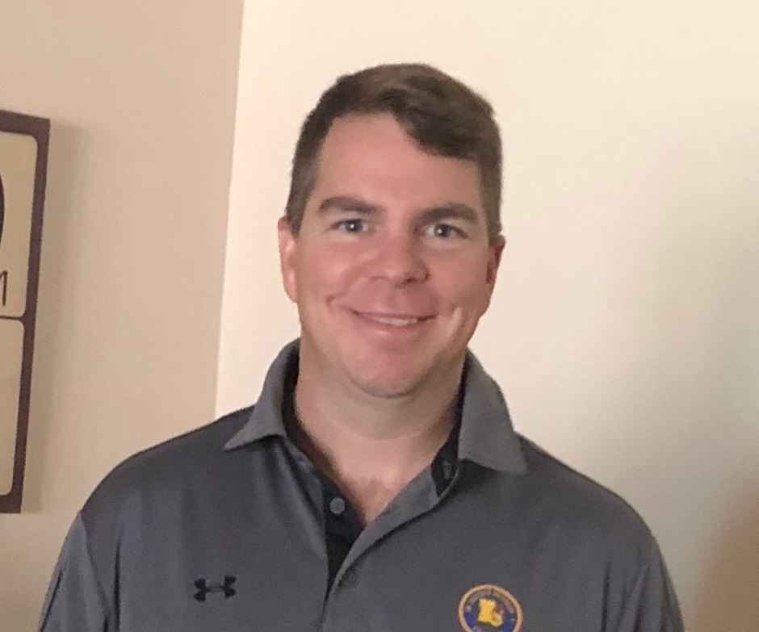
CDR Malokofsky was born in Cubi Point, Philippines, in 1978. He earned his Bachelor’s degree from Ferris State University in 2001 and proceeded to Officer Candidate School where he was commissioned an Ensign in April, 2002. Designated a Naval Aviator in September, 2003, he was assigned MH-53Es and ordered to fleet replacement squadron training at Airborne Mine Countermeasures Weapon Systems Training School (AWSTS) in Norfolk, VA.
CDR Malokofsky’s first fleet assignment was to the "Blackhawks" of Helicopter Mine Countermeasures Squadron FIFTEEN (HM-15) in Corpus Christ, TX. He qualified as Aircraft Commander, AMCM Mission Commander, and Functional Check Pilot while holding numerous ground positions to include Legal Officer, multiple Maintenance Divisions, Admin Officer, and Quality Assurance Officer. He deployed twice in support of Operation ENDURING FREEDOM and participated in Operation LIFELINE-Pakistan supporting earthquake relief efforts in 2005. He was also designated as the Assistant Officer-in-Charge (AOIC) for HM-15’s deployment to the multi-national exercise PANAMAX-06.
In August 2007, CDR Malokofsky reported to Helicopter Training Squadron TWENTY-EIGHT (HT-28). One year later, he was tasked to Training Air Wing FIVE (TRAWING-5) to lead all four helicopter squadrons in Operational Risk Management and to teach Instrument Flight Rules to all incoming students and instructors. He achieved standardization qualifications for Category-1 and Category-2 instruction. His last year there, CDR Malokofsky was moved to the safety position at Helicopter Instructor Training Unit (HITU) to teach all incoming flight instructors on the fundamentals of the TH-57 and instructor techniques. He also earned his JPME through distance education from the Naval War College.
After a year-long volunteered Individual Augmentee assignment as the OIC of a Military History Detachment assigned to Southeast Afghanistan, he was detailed to Monterey to Naval Postgraduate School, curriculum 691- Homeland Defense and Security, graduating in December, 2012, with a Master’s degree in National Securities Affairs.
CDR Malokofsky was assigned to HM-15 once again, this time as a Department Head, where he served as the MCM MO, Det OpsO, Det TWO OIC, and finishing as the Operations Officer for the Navy’s largest helicopter squadron, earning the Battle E all three years.
Staying in Norfolk, CDR Malokofsky volunteered for back-to-back sea duties, taking an assignment to Tactical Air Control Squadron TWO-ONE (VTC-21). As the Expeditionary Department Head, he deployed as the AOIC for the squadron and the PMC Officer in support of the USS BATAAN ARG. He also was the squadron’s AOIC for humanitarian assistance during the hurricane relief efforts in Haiti onboard the USS IWO JIMA.
CDR Malokofsky is currently assigned as the Commanding Officer for Southern University and A&M College Naval ROTC. His personal decorations include the Defense Meritorious Service Medal, Navy Commendation Medal (4), Navy Achievement Medal (3), Military Outstanding Volunteer Service Medal, and numerous other unit and campaign awards. CDR Malokofsky is married to Kathlena, and they have four children together: Gwenith, Logan, Quinn, and Dylan.

