THE SPRING SEMESTER WRAP UP
WHO AM I?!
My name is Staff Sergeant Boyd (soon to be Lieutenant on MAY 14! YEA!). My primary responsibility here is to help with the training and development of the Marine Option Midshipmen and to help foster an arduously competitive environment of dedication, sacrifice, challenge and rigor while maintaining the camaraderie and friendship that we Marines hold high. I have been at the unit for three years now and have seen it grow tremendously, inside and out. I have watched the growth of all the Marine Options and can say with conviction that Southern University is on track to produce some of the brightest, hardworking, and best prepared Marine Officers of nation has to offer.
  - THE MARINE OPTIONS

Naval Reserve Officers Training Corps, Southern University and A&M College
2016
“What Seperates the boys from the men, the champions from the defeated, and the living from the dead is the ability and willingness to take the percision shot without hesitation"
Hello Families!!
We are so excited to bring to you, an official Marine Option Newsletter encapsulating the progress and accomplishments that we’ve done this semester!
Each semester a Marine Option will be in charge of creating this awesome Newsletter (with the help of the others of course! When do we ever do anything alone?!) To kick it off, I have volunteered to go first!
With that said, let’s get into what we’ve been up to this semester!
As Marines (and future Marines), we always want to improve and continue to get better, and the start of spring 2016 didn’t disappoint. We hit the ground running and quickly learned that many of us had too much holiday yum-yums, and forgot that we needed to maintain our fitness. Therefore, the first week back our bodies were shocked but ready to get back to where we left off. It took about three weeks but we all stepped it up and are learning that training is a way of life in the Corps, not something we can pick and choose when to do. I am happy to say that as we put a close to the semester, our physical fitness averages are at an all-time high with 2 Marine Options ducking under a 20 minute 3 mile run and a 3rd midshipman right on the cusp of a breakthrough as well! We all know what we need to work on and we are doing an excellent job of accepting those challenges and attacking them head on. Now let’s talk about some events! Our first major event was the Mardi Gras Drill Meet and parades where we all got to walk in a parade and represent our unit. MIDN Hernandez had the opportunity to compete with the color guard at the Tulane Drill Meet. Our Biggest event for the Marine Options came two weeks later where we linked up with the local Officer Selection Office and conducted a three day field exercise at Camp Shelby in Hattiesburg, MS. It is here where we gain the best inside experience to what it will be like when we get the opportunity to go to Officer Candidate School (OCS). Sparing the fun details (ask your Marine Options), we covered everything; a 6 mile hike with a simulated combat load, a live simulator of High Mobility Multipurpose Wheeled Vehicle (HMMWV) rollover training , several rounds of the Leadership Reaction Course and a mountain of OCS instruction and information. All that thrown together with a little stress and chaos made for an excellent exercise, and one where we stood out and were often looked to for guidance and direction by the other Marine Officer hopefuls that attended.

We Stay busy and always involved!!
AREA EIGHT DRILL MEET, MIDTERM PERFORMANCE, FLIGHT CONTRACTS and MORE

Just seven days later, following our field exercise, we jumped onboard with the AREA Eight Drill Meet. This is a Junior ROTC (high School) meet were several (about 15-20) high schools bring their JROTC Teams to Southern University to compete in one of the few regional qualifying meets. This meet is put on entirely by Navy and Marine Midshipmen and requires precision in planning and delegation of duties. As Marine Options, we dove right in to the toughest judging task on the drill deck, the Inspection. The Marine Options came up with a brilliant plan to expedite the inspections of every high school by increasing the number of inspector from 5 to 10. This allowed the inspections to finish twice as fast as usual (it’s the very first event and usually causes a bottleneck at the meet). This opened up some white space for the schools allowing them to flow effortlessly through their events; making this year’s drill meet, the highest rated meet that Southern has ever seen (ratings done anonymously by JROTC instructors)!
Once the Meet concluded it was time for us all to gear up for mid-term exams and then a much needed spring break. Our midterm PFT showed great improvement in averages but it also showed the importance of recovery and rest, we couldn’t wait for Spring Break!
After our return from the break we continued to train, and we also began to work on our scholarship packages and flight contract submissions. Congratulations to MIDN Escajeda for receiving the Frederick C. Branch Scholarship and to MIDN Spears, J and MIDN Niedermair for receiving flight contracts (two days after submission, that’s insanely fast for the Marine Corps)! MIDN Holl is hopeful that his package will be approved as well, after just finishing the ASTB exam with the highest grade we’ve had to date! Congrats!!
Other fun things going on: Many of the Marine Options played on an LSU intramural Softball team where we made it to the second of 4 rounds of the championship tournament. Good Job Marine Ops!
We are all looking forward to the Final PFT to see how much we have improved physically and we are motivated to witness the commissioning of our graduating seniors! Until the next newsletter, take care Family, remember to support your Marine Options in every way and continue to love and motivate, so that they will remember, each day, the reasons they have decided to support and defend their country! Semper Fidelis.
u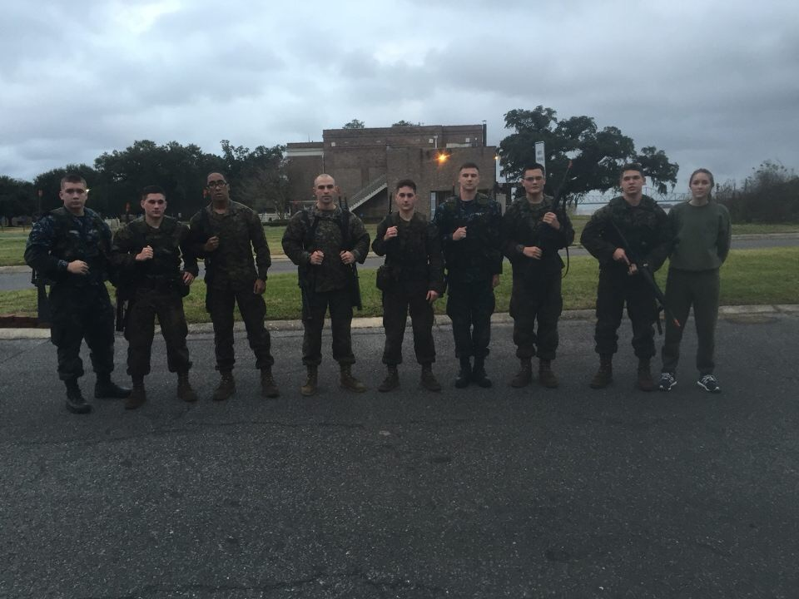
THE Marine Options and Staff Sergeant Boyd, after crushing the Endurance Course
(From left to right: MIDN Hernandez, Spears, Peoples, SSgt Boyd, Spears, Escajeda, De Boisblanc, Niedermair, France)

