Experiment (2) Using a solar panel to power a small fan/wheel motor module:

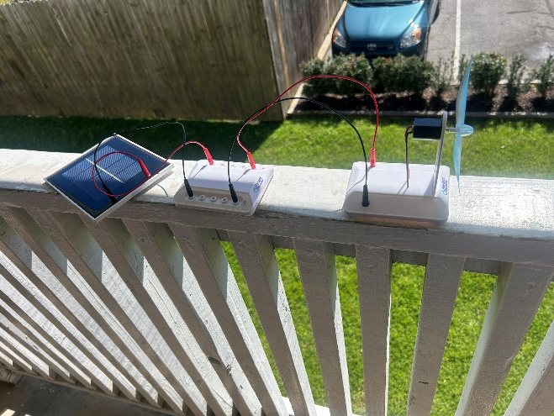
(i). List of Components
Solar Panel (provided in the kit)
Fan/Wheel Motor Module (provided in the kit)
Connecting Wires (Red and Black for positive and negative terminals.
(ii). Experiment Objectives
- To demonstrate the conversion of solar energy into electrical energy to power a fan/wheel motor.
- To understand how light intensity affects the power output of a solar panel.
- To observe the relationship between voltage, current, and mechanical motion in a basic solar-powered system.
(iii). Procedures
- We positioned the Solar Panel under direct sunlight and adjusted the angle of the panel to maximize exposure to the light source.
- We connected the Motor Module while Identifying the positive (+) and negative (-) terminals of both the solar panel and the motor module.
- We used the red wire to connect the positive terminal of the solar panel to the positive terminal of the motor module and used black wire to connect the negative terminal of the solar panel to the negative terminal of the motor module.
- We Observed the Fan Rotation, indicating successful energy conversion.

(iv). observation
A higher light intensity leads to a faster fan speed, demonstrating that solar panel output depends on illumination levels.
The performance of the solar-powered fan depends on the amount of sunlight or artificial light available, making solar energy a viable but variable power source.
(v). Precautionary Measures Taken
- We ensured correct wiring of positive and negative terminals to prevent circuit failure.
- We used sufficient light intensity from the sun to generate adequate power for the fan.
- We ensured secure and stable connections between the solar panel and the motor module.
- We Kept the solar panel clean and free from obstructions for maximum efficiency.

