Experiment (1) Using a solar panel to power an LED module

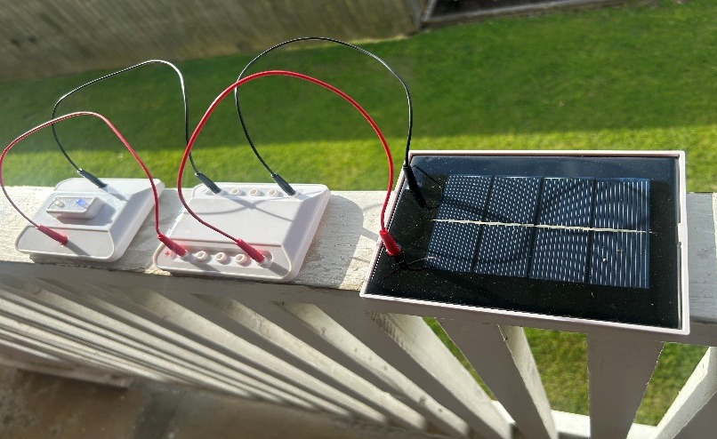
(i). List of Components
- Solar Panel (provided in the kit)
- Connecting Wires (Red and Black for positive and negative terminals)
- Circuit board
- LED module
(ii). Experiment Objectives
- To demonstrate the conversion of solar energy into electrical energy.
- To use the electricity generated from the solar panel to power an LED module.
- To understand the basic principles of solar power and electrical circuits.
(iii). Procedures
After setting up the Solar Panel,
We placed the solar panel under sunlight, ensuring that the panel is positioned at an optimal angle for maximum light absorption. Strong artificial light sources can also be used to achieve this in the event of no sunlight.
We connected the LED Module while Identifying the positive (+) and negative (-) terminals of both the solar panel and the LED module.
We used the red wire to connect the positive terminal of the solar panel to the positive terminal of the LED module. We also used the black wire to connect the negative terminal of the solar panel to the negative terminal of the LED module.
We observed the LED Module light up, hence confirming the successful conversion of solar energy into electrical energy.
If the LED lights up, it confirms the successful conversion of solar energy into electrical energy.
(iv). Precautionary Measures Taken
- We ensured proper connection of positive and negative terminals to prevent incorrect wiring.
- We used a bright light source or direct sunlight for efficient solar energy conversion.
- We ensure firm and secure wire connections to avoid loose connections disrupting the circuit.
- We avoided exposure of the solar panel to extreme heat to prevent damage.

