Experiment (10) Using the battery pack to perform Electrolysis (no sun or no wind)

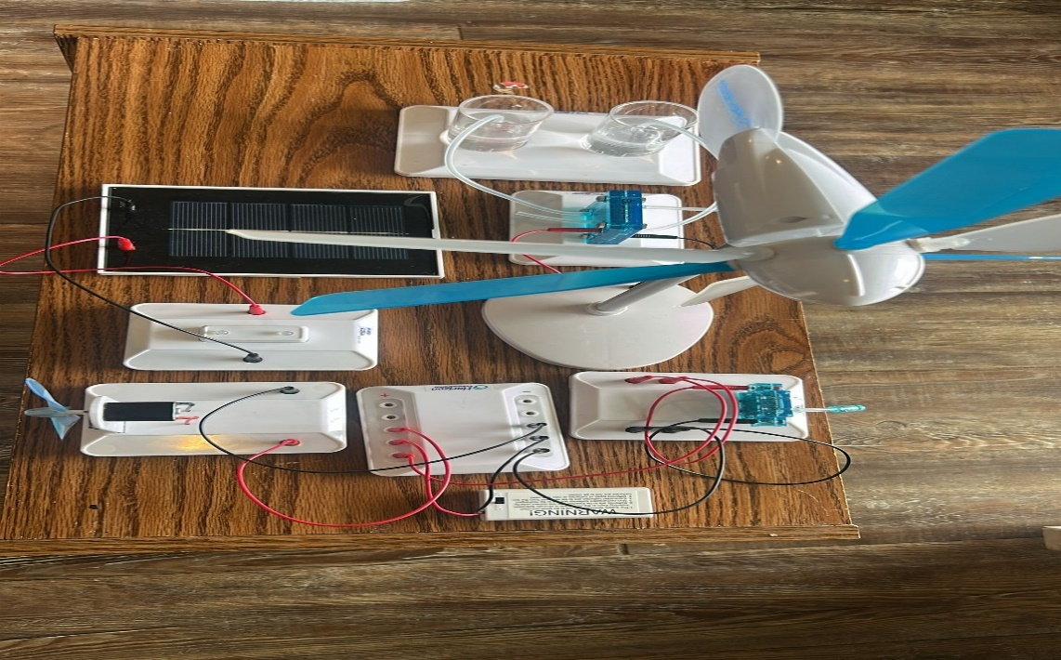
(i) Components Used
- Horizon Electrolyzer Module
- Hydrogen and Oxygen Gas Cylinders
- Battery Pack (as DC power source)
- Connecting wires (Red and Black)
- Circuit terminal board
- Mounting bases and electrolyte tubes
(ii) Objectives
- To simulate electrolysis in the absence of renewable energy sources like sun or wind
- To observe water splitting using a constant DC supply (battery pack)
- To collect and store hydrogen and oxygen gases for later use in a fuel cell
(iii) Procedure
- We made sure the battery pack was set up on the terminal board and securely wired for output.
- The red (positive) and black (negative) wires from the battery were connected to the electrolyzer module’s corresponding terminals.
- The electrolyzer was connected via tubing to two water-filled cylinders meant for collecting hydrogen and oxygen.
- The battery was turned ON to supply power.
- As the current flowed through the electrolyzer, electrolysis of water began — generating hydrogen gas at the cathode and oxygen gas at the anode.
- The gases were collected and visibly stored in the attached cylinders.

(iv) Observations
- Gas bubbles were seen forming within seconds, confirming the electrolysis reaction.
- Hydrogen filled one cylinder at approximately twice the volume of oxygen in the other — validating the chemical ratio H₂:O₂ = 2:1.
- The reaction proceeded continuously as long as the battery was active.

(v) Precautionary Measures
- We ensured battery pack output matched electrolyzer voltage/current requirements.
- We verified polarity to avoid damage to the electrolyzer module.
- We avoided short circuits or wire tangling.
- We ensured tight tubing to prevent leakage of hydrogen and oxygen gases.
- We conducted experiments in a ventilated space to avoid gas accumulation.

