Experiment (3): Preparation of the electrolyzer module and solar-powered hydrogen production.

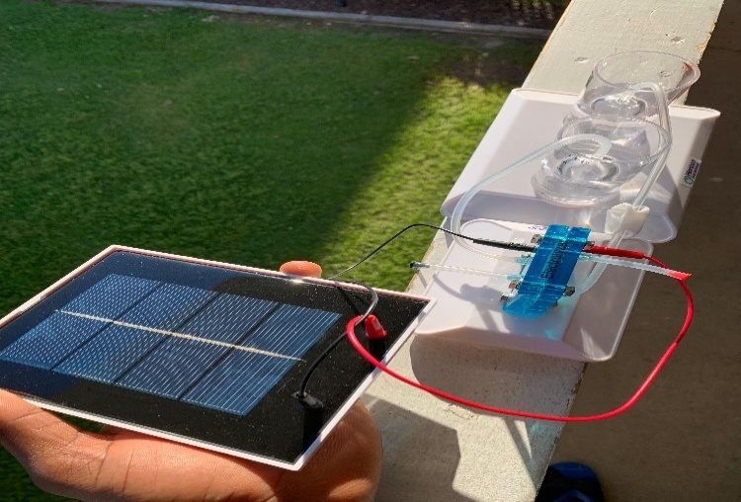
(i). List of Components
- Solar Panel (provided in the kit)
- Electrolyzer Module (provided in the kit)
- Distilled Water (essential for electrolysis)
- Connecting Wires (Red and Black for positive and negative terminals)
- Tubing and Water Reservoirs (for collecting hydrogen and oxygen gases)
- Sunlight
(ii). Experiment Objectives
To demonstrate how solar energy can be used to produce hydrogen through electrolysis.
To observe the splitting of water (H₂O) into hydrogen (H₂) and oxygen (O₂) using an electrolyzer module.
To understand the potential of hydrogen as a renewable and clean energy source.
(iii). Procedures
We prepared the Electrolyzer Module, Filled the water reservoirs with distilled water, ensuring that the tubes are properly connected to allow gas collection.
We Connected the Solar Panel and Placed it under direct sunlight.
We Identified the positive (+) and negative (-) terminals on both the solar panel and the electrolyzer module and used the red wire to connect the positive terminal of the solar panel to the positive terminal of the electrolyzer. We also used black wire to connect the negative terminal of the solar panel to the negative terminal of the electrolyzer.
(iv). observation
- The electrolyzer started splitting water into hydrogen and oxygen gases, which were collected in the separate chambers.
- Hydrogen (H₂) accumulated in one chamber, while oxygen (O₂) collected in the other.
- Bubbles forming in the water reservoirs indicate successful electrolysis
- The amount of gas produced should correlate with the intensity of the light and the efficiency of the electrolyzer.
- This experiment successfully demonstrates how solar energy can be converted into electrical energy to perform water electrolysis.
- Hydrogen can be stored and later used as a clean fuel source, showcasing its potential in renewable energy applications.
(v). Precautionary Measures Taken
- We used only distilled water to avoid impurities that could affect the electrolysis process.
- We ensured correct polarity when connecting wires to avoid damaging the electrolyzer.
- We maintained proper tube connections to allow gas collection without leakage.
- We avoided exposure of the setup to excessive heat, which could interfere with performance.
- We handled the produced hydrogen carefully, as it is flammable.

