Experiment (4) using a PEM fuel cell to power the LED module.
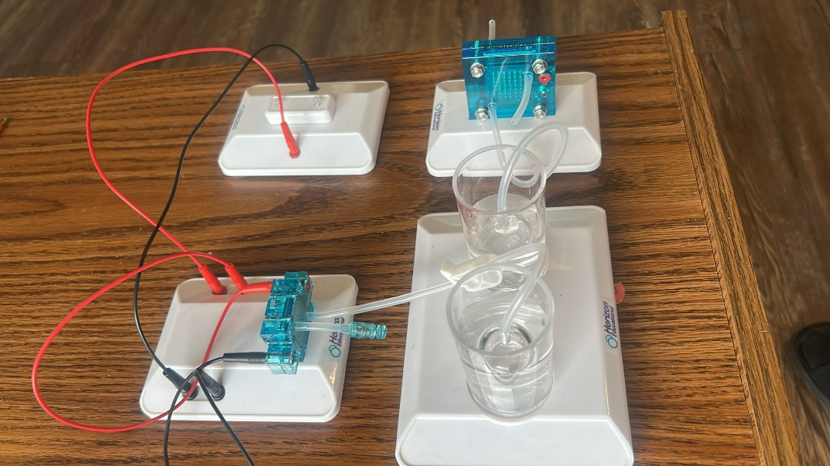
(i) List of Components
- PEM Fuel Cell (from the provided kit)
- Hydrogen Storage Unit (from Experiment 3)
- LED Module (provided in the kit)
- Connecting Wires
- Water Reservoirs & Tubing (for hydrogen and oxygen flow)
(ii) Experimental Objectives
To Set up a PEM fuel cell system using hydrogen as the fuel source, establishing proper electrical connections to power the LED module.
(iii) Procedures
We properly assembled the fuel cell according to the kit instructions.
We connected the hydrogen storage unit (from Experiment 3) to the anode side of the fuel cell, allowing oxygen from the air to flow to the cathode side of the fuel cell.
We then ensured that all tubing and connections are secure to prevent leaks.
Using connecting wires, we attached the positive terminal of the fuel cell to the positive terminal of the LED module. Also, we Connected the negative terminal of the fuel cell to the negative terminal of the LED module.
Once the hydrogen supply is active, we observed that the LED module light up.

(iv) Results and Conclusion
This experiment successfully demonstrates how a PEM fuel cell system can generate electricity from hydrogen and oxygen to power an LED module. The results confirm that hydrogen fuel cells can serve as a renewable power source for low-power electronic applications.
LED Module Status: (ON/OFF, brightness observation)
(v) Precautionary Measures Taken
We ensured secure and leak-proof hydrogen connections.
We used proper ventilation to prevent hydrogen buildup.
We checked polarity before connecting the LED module.
We avoided short-circuiting by correctly wiring the fuel cell.

