Experiment (5) using PEM fuel cells to power the small electric fan module.
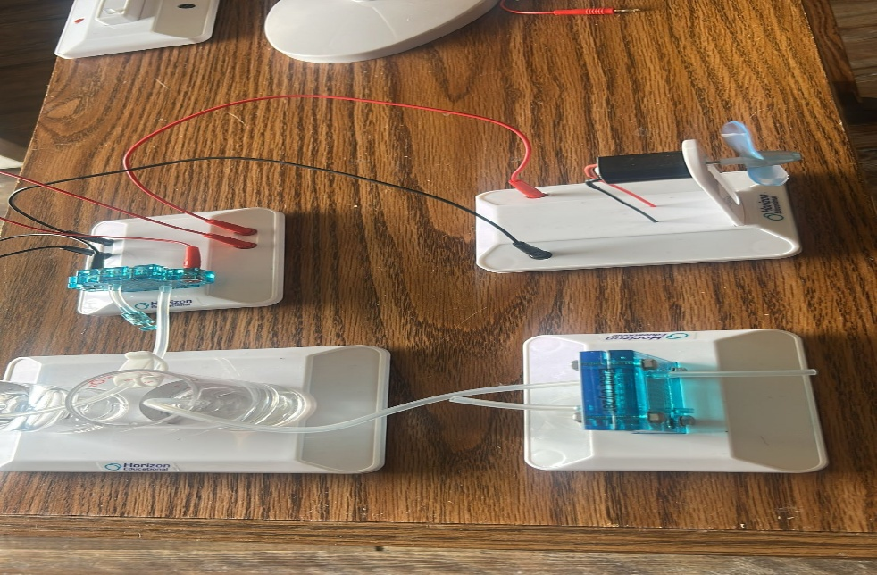
(i)List of Components
- PEM Fuel Cell (provided in the kit)
- Hydrogen Storage Unit (generated from Experiment 3)
- Small Electric Fan Module
- Connecting Wires
- Water Reservoirs & Tubing (for hydrogen and oxygen flow)

(iii)Procedures
Step 1: Setting Up the PEM Fuel Cell
We assembled the PEM fuel cell according to the provided instructions, connecting the hydrogen storage unit (from Experiment 3) to the anode side of the fuel cell.
We allowed oxygen from the air to flow to the cathode side of the fuel cell, ensuring that all tubing and connections are securely fitted to prevent leaks.
Step 2: Establishing the Electrical Circuit
Using connecting wires, we attach the positive terminal of the fuel cell to the positive terminal of the fan module and connected the negative terminal of the fuel cell to the negative terminal of the fan module.
Step 3: Powering the Electric Fan Module
Once the hydrogen supply is active, we observed that the fan blades began to spin.
Monitor the rotation speed and record any voltage fluctuations.

(iv) Conclusion
This experiment successfully demonstrates how a PEM fuel cell system can generate electricity from hydrogen and oxygen to power a small electric fan module. The results confirm that hydrogen fuel cells can be a reliable renewable energy source for low-power applications.

(v) Precautionary Measures Taken
- We ensured secure and leak-proof hydrogen connections.
- We used proper ventilation to prevent hydrogen buildup.
- We checked polarity before connecting the fan module.
- We avoided short-circuiting by correctly wiring the fuel cell.

