Experiment (6) Using a PEM Fuel cell to Power the Small Car Wheel Module
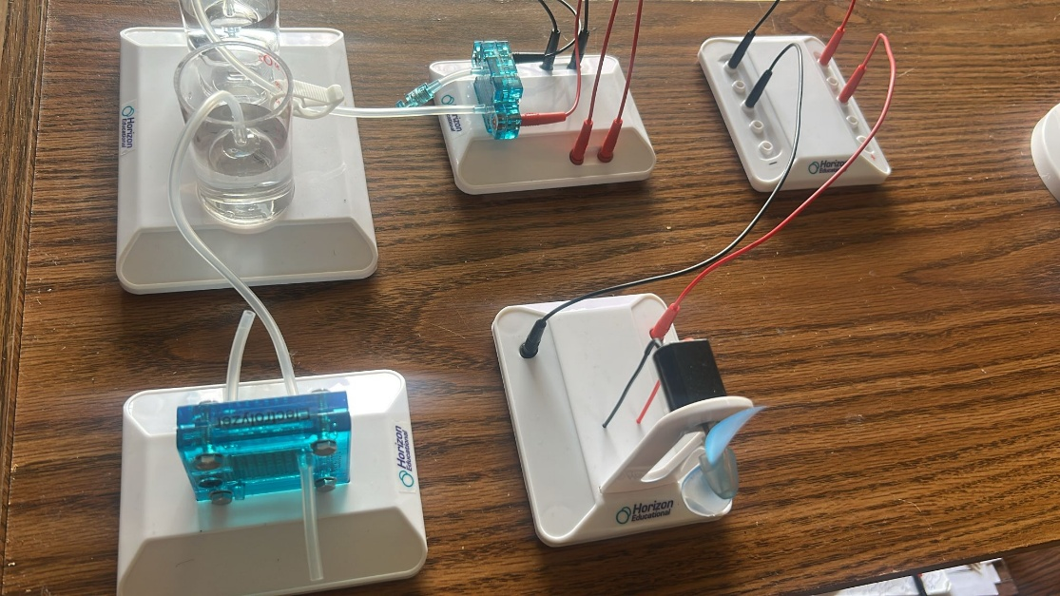
(i) Components Used
- PEM Fuel Cell
- Hydrogen and Oxygen storage cylinders
- Water supply and electrolyte tubes
- Connecting wires (Red and Black)
- Small car wheel module (motorized propeller)
- Stand and support base
(ii) Objectives
- To demonstrate the generation of electricity using a PEM fuel cell
- To convert chemical energy (from hydrogen and oxygen) into electrical energy
- To power a mechanical load (small car wheel module) using fuel cell output
- To explore real-world hydrogen energy applications
(iii) Procedure
- First, we ensured the hydrogen and oxygen storage cylinders were filled using an electrolyzer (charged earlier using solar panel in previous experiments).
- The PEM fuel cell was connected to the gas cylinders using the correct tubing (ensuring no leaks).
- We connected the output terminals of the PEM fuel cell to the small car wheel module using red (positive) and black (negative) wires.
- Upon successful connection, hydrogen began to flow into the fuel cell, initiating the electrochemical reaction.
- The car wheel module's propeller began to spin, indicating that the fuel cell was generating electricity and powering the motor.
(iv) Observations
- The fan/wheel started spinning a few seconds after connection — confirming successful power generation.
- Speed was moderate, suggesting steady hydrogen flow.
- Once hydrogen depleted, the module slowed and stopped — confirming hydrogen was the only power source.
- No noise or pollution was observed, demonstrating a clean energy process.
(v) Precautionary Measures
- We verified all tube connections to avoid gas leakage.
- We Checked the polarity of electrical connections before powering the module.
- We ensured the fuel cell was dry and clean before use.
- We kept hands and wires away from the spinning motor for safety.
- We performed the experiment in a well-ventilated space.

