Experiment (7) Using a PEM Fuel Cell to Power the Small Fan/Wheel Motor Module and LED Module in Parallel
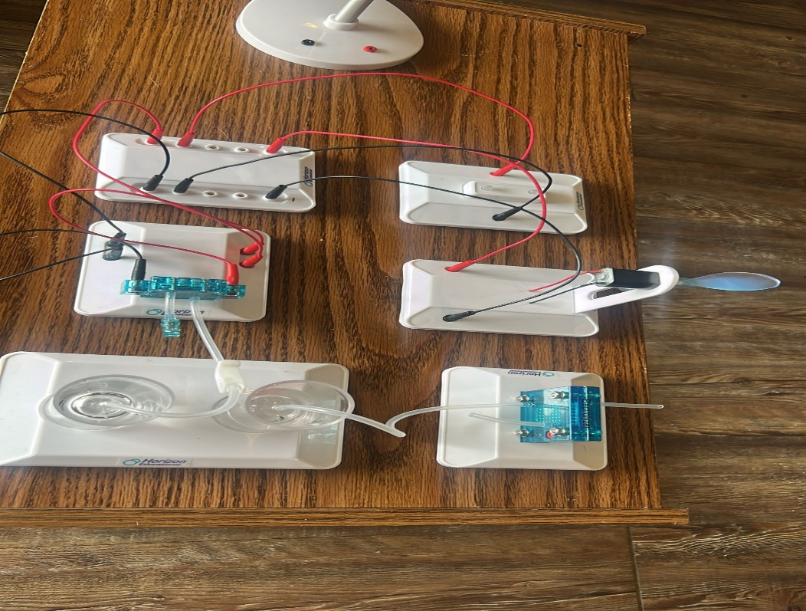
(i) Components Used
- PEM Fuel Cell
- Hydrogen and Oxygen gas cylinders
- Tubing for gas transfer
- Connecting wires (red and black)
- Small fan/wheel motor module
- LED module
- Parallel circuit board / multiple terminal block
(ii) Objectives
- To demonstrate simultaneous powering of two loads (mechanical + electrical) using a PEM fuel cell
- To understand parallel circuit configurations
- To explore the performance of a fuel cell under multiple load conditions
- To simulate hybrid clean energy use (lighting + motion)
(iii) Procedure
- First, we did gas preparation: Hydrogen and oxygen gases were first generated and stored using the electrolyzer (as done in earlier experiments).
- Fuel Cell Setup: Gas tubes were connected securely to the PEM fuel cell to allow the electrochemical reaction to begin.
- Parallel Wiring
- The fan/wheel module and LED module were connected in parallel using a common connection board.
- The red (positive) terminals of both modules were connected together and linked to the PEM fuel cell’s positive output.
- Likewise, black (negative) terminals were grouped and connected to the fuel cell’s negative output.
- Power Activation: Once connected, hydrogen flow began powering the fuel cell.
- The LED lit up and the fan motor spun at the same time, confirming both loads were successfully powered.
(iv) Observations
- Both the LED and the fan turned on simultaneously, with stable brightness and speed.
- The fan speed was slightly lower than in the standalone test (Experiment 6), due to shared power.
- The LED maintained steady brightness, showing the effectiveness of the parallel setup.
- When hydrogen was depleted, both outputs dropped evenly and stopped together.
(v) Precautionary Measures
- We double-checked polarity before making parallel connections.
- We used solid, stable wiring to avoid short circuits across the modules.
- We ensured the PEM fuel cell was not overloaded beyond its capacity.
- We operated the setup in a well-ventilated area due to gas handling.
- We avoided touching the fan blades or terminals during operation.

