Experiment (8) Using a Wind Turbine to Power the LED Module
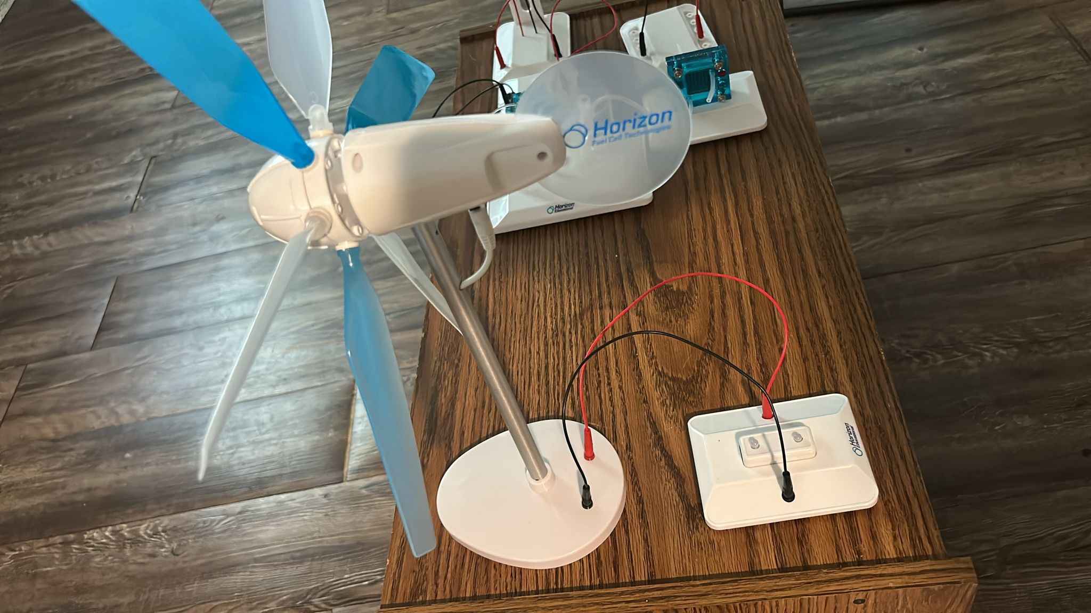
(i) Components Used
- Wind Turbine Generator (Horizon model)
- LED module
- Connecting wires (Red and Black)
- Terminal board or connection base
- Fan or air source (optional for demonstration indoors)
(ii) Objectives
- To demonstrate how wind energy can be converted into electrical energy
- To light up an LED using the output from a wind turbine
- To understand the basic functionality of wind turbines in renewable energy systems
- To observe the impact of blade speed (wind speed) on electrical output
(iii) Procedure
- First, we made sure the wind turbine was assembled and mounted in an upright position using its vertical stand.
- The red (positive) and black (negative) wires from the turbine were connected to the LED module via the terminal block.
- The turbine was either manually spun or exposed to a fan (if indoors) to simulate wind conditions.
- As the blades rotated, the turbine converted kinetic energy from the wind into electrical energy.
- The LED was observed closely to detect illumination as the turbine blades accelerated.
(iv) Observations
- The LED lit up when the turbine blades spun at a sufficient speed.
- As blade speed increased, the LED brightness increased slightly — showing a correlation between turbine speed and voltage output.
- Under low or no wind, the LED remained off, demonstrating that wind is the sole power source.
- The setup was successful in showing direct wind-to-electric conversion.
(v) Precautionary Measures
- We ensured correct polarity when connecting the LED module to prevent damage.
- We mounted the turbine securely to prevent tipping during operation.
- We Avoided placing hands near spinning blades to prevent injury.
- We used soft, controlled airflow when simulating wind indoors.
- We double-checked all connections for tightness and continuity.

