Experiment (9) Preparation of the Electrolyzer Module and wind powered hydrogen production

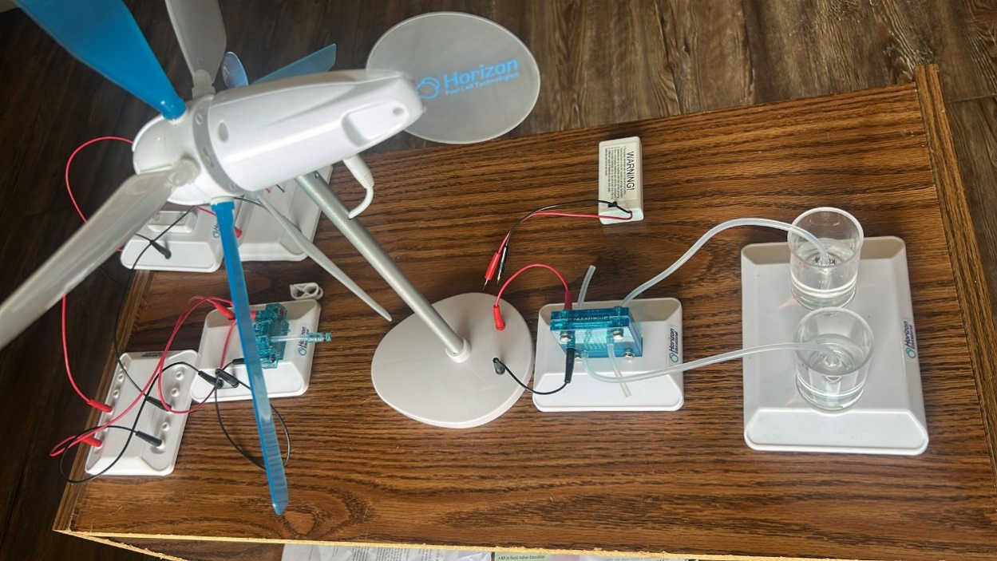
(i) Components Used
- Wind Turbine Generator (Horizon model)
- Electrolyzer module
- Hydrogen and oxygen storage cylinders
- Water-filled electrolyte tubes
- Red and black connecting wires
- Mounting and connector bases
(ii) Objectives
- To demonstrate the conversion of wind energy into chemical energy
- To use electricity generated by a wind turbine to split water into hydrogen and oxygen using an electrolyzer
- To observe the storage of hydrogen and oxygen in respective cylinders for later use in a PEM fuel cell
- To reinforce the concept of renewable energy storage
(iii) Procedure
- We first mounted the wind turbine on its base in a secure position.
- Red and black wires were used to connect the output of the wind turbine directly to the electrolyzer module.
- Two water-filled gas cylinders were connected to the electrolyzer using gas transfer tubing — one for hydrogen (H₂) and one for oxygen (O₂).
- When wind (or fan air indoors) caused the turbine blades to spin, electricity was generated and sent to the electrolyzer.
- The electrolyzer initiated electrolysis of water, resulting in visible gas bubble formation inside each cylinder.
- The system was left to operate until a noticeable volume of hydrogen and oxygen was collected for fuel cell use.
(iv) Observations
- Bubbles quickly formed in both gas cylinders, indicating active water splitting.
- Hydrogen was generated at approximately twice the volume of oxygen (H₂:O₂ = 2:1).
- The process began as soon as the turbine reached a minimum rotation speed.
- This clean, quiet process effectively showcased energy storage from wind.
(v) Precautionary Measures
- Confirmed water levels in the electrolyzer and gas cylinders before operation.
- Ensured tight, leak-free connections between tubes and cylinders.
- Checked turbine wiring polarity to ensure correct electrolysis direction.
- Handled the system gently to avoid tube dislodgement.
- Performed the setup in an open or well-ventilated space due to gas production.

